**Class: T14**

**Name: Dominic Lee**

**ID: S10222894**

**Index No: 15**

**Title: WISP Assignment 2**

**UN SGD chosen: Clean Water & Sanitation**

**Target: 6.3 Improve water quality, wastewater treatment and safe reuse**

**Country: India**

**Word Count: 499**

1. **Provide a brief introduction on your chosen country in relation to the target chosen. Why is the target important to the country? (8 marks)**

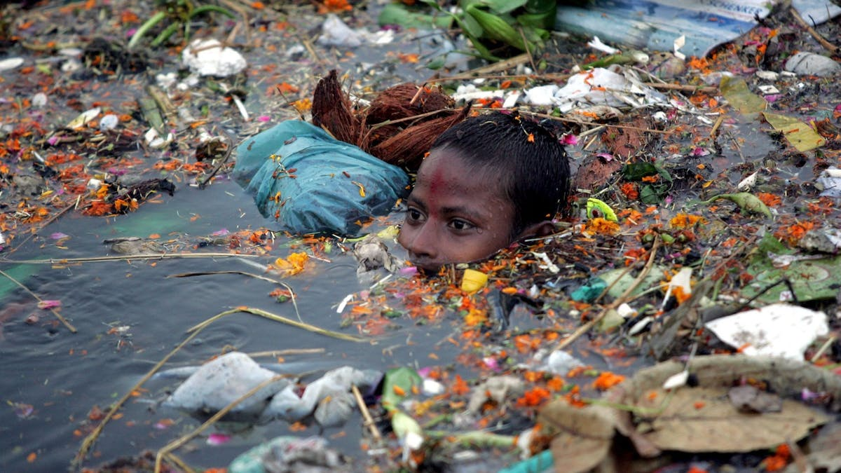

**1** Child in India swimming in polluted water

(theconversation, 2015; Gupta, 2021)

India is suffering from a severe lack of clean water and sanitation. More than 6% of its population lacks access to clean water, 344 million lack access to toilets, and 10% of deaths are related to hygiene standards (water.org, n.d.). Worse still, experts predict that 40% of its citizens will not have access to a clean water source by 2030 (Sharudenko, 2020). Lastly, 80% of India’s water sources are severely polluted due to dumping and open defecation with approximately 15% of its citizens practicing open defecation.

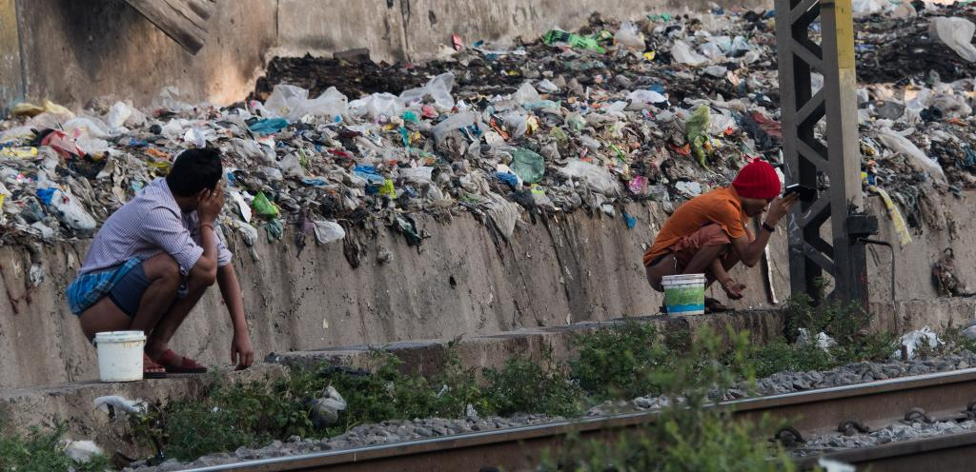

2 People practicing open defecation in India

(downtoearth, n.d.)

This need for clean water and sanitation results in social, economic, and physical problems for India. For instance, water relates to more than 20% of diseases in India (Zhang, 2020). 44 million children under five are malnourished as their only source of water is contaminated groundwater and 300,000 die annually from diarrheal diseases (A.A.K., 2017). India also loses $80 billion annually due to poor water health which greatly affects the revenue of certain sectors such as agriculture (Sharudenko, 2020). Lastly, many women and children are vulnerable to assault as they have no toilets to safely defecate in.

**What are the challenges faced by the country in relation to the target? (6 marks)**

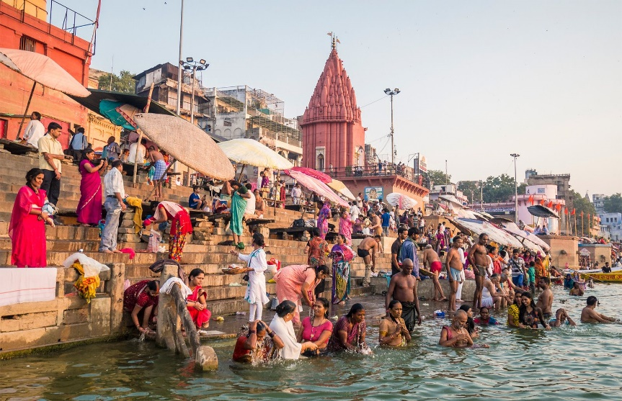

**3** Hindu pilgrims bathing in the Ganges River, India

(Britaannica, n.d.)

Citizens having bad environmental habits as well as the hefty cost to obtain clean water and sanitation are challenges faced by India. Over 40% of households with a working latrine have at least one member who defecates in the open, contaminating the environment, as they find it more pleasurable and desirable (Coffey, et al., 2014). Additionally, the Ganges River which provides water for 40% of India’s population (Wikipedia, n.d.) is subject to over 75% of untreated sewage from cities, human waste, and thousands of human corpses dumped in during festive seasons (Wikipedia, n.d.). Financially, even though India has spent $18.8 billion on their water industry in the last 4 years, it would still take 3.2% of India’s estimated GDP by 2030 to have sustainable water management. Making India’s investment in water as a proportion of its GDP among the highest in the world (Paliath, 2021).

1. **What is one initiative the country has implemented to achieve this target? To what extent has it been effective (provide an evaluation of its effectiveness)? (8** 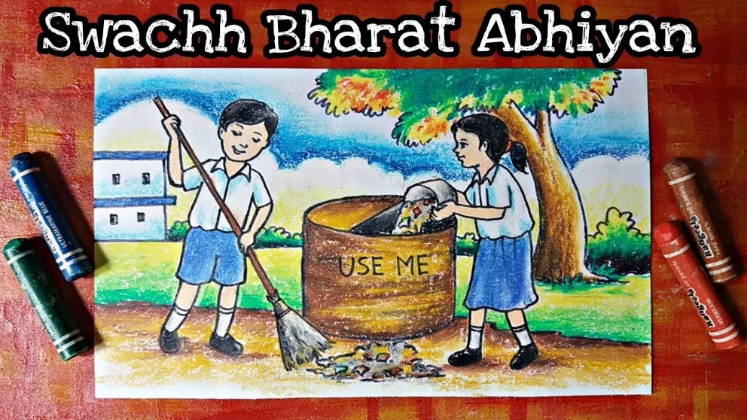

**4**  A crayon drawing of Indian school children cleaning up waste because of the Swachh Bharat Mission

(Gupta, 2021)

The Swachh Bharat mission was kickstarted in 2014 to eliminate open defecation in India as human faeces contains many types of germs and open defecation greatly increases the spread of these germs which leads to diseases such as typhoid. $17.7 billion was dedicated to building over 100 million toilets across India, especially in rural areas where open defecation was more prevalent (Kapur-Gomes, 2020). The mission also aimed to change Indian’s mindset when it came to open defecation. Celebrities as well as educational materials were used to spread awareness and stigmatize open defecation to persuade people to break the habit (Kapur-Gomes, 2020).



5 Pickpocket stealing money

However, the actual number of toilets built is inflated. Due to a lack of verification by the government, much of the funds dedicated are pocketed by people in power, resulting in poor quality toilets built (Kapur-Gomes, 2020). Also, a lack of ownership causes the toilets built to be extremely dirty and in disrepair after a short time (Kapur-Gomes, 2020).

It is found that Open defecation free (ODF) villages were 12.7 times less likely to have groundwater contaminated with human faeces (unicef, 2019). And Swachh Bharat was successful at helping 100 million households and 500 million citizens gain access to toilets over 630 000 villages (The Economic Times, 2019). Hence, I would consider it a success.

# Bibliography

A.A.K. (2017). *Why is it so hard to fix India's sanitation?* Retrieved from The Economist: https://www.economist.com/the-economist-explains/2017/09/24/why-it-is-so-hard-to-fix-indias-sanitation

Britaannica. (n.d.). Retrieved from britannica.com: https://www.britannica.com/place/Ganges-River/Climate-and-hydrology

Coffey, D., Gupta, A., Hathi, P., Khurana, N., Spears, D., & Srivastav, N. (2014). *Revealed Preference for Open Defecation: Evidence from a new survey in rural north India (longer working paper)*. Retrieved from riceinstitute.org: https://riceinstitute.org/research/revealed-preference-for-open-defecation-evidence-from-a-new-survey-in-rural-north-india-longer-working-paper/

downtoearth. (n.d.). Retrieved from cdn.downtoearth.org.in: https://cdn.downtoearth.org.in/library/large/2017-09-07/0.01724400_1504791575_odf-sharada-prasad-cs---flickr.jpghttps://cdn.downtoearth.org.in/library/large/2017-09-07/0.01724400_1504791575_odf-sharada-prasad-cs---flickr.jpg

Gupta, T. (2021). Retrieved from medium.com: https://medium.com/@tapashigupta/has-the-swachh-bharat-mission-been-a-success-or-failure-a91f23dfa03b

Kapur-Gomes, S. (2020). *India spent $30 billion to fix its broken sanitation. It ended up with more problems*. Retrieved from CNET: https://www.cnet.com/culture/india-spent-30-billion-to-fix-its-broken-sanitation-it-ended-up-with-more-problems/

Paliath, S. (2021). *India will have to spend more in Budget 2021 to provide tap water to all its rural homes*. Retrieved from Scroll.in: https://scroll.in/article/985327/india-will-have-to-spend-more-in-budget-2021-to-provide-tap-water-to-all-its-rural-homes

Sharudenko, A. (2020). *How Water Pollution in India Kills Millions* . Retrieved from Borgen Magazine: https://www.borgenmagazine.com/water-pollution-in-india/

The Economic Times. (2019). *Rural India achieved 100 pc ODF status: Govt*. Retrieved from economictimes: https://economictimes.indiatimes.com/news/politics-and-nation/rural-india-achieved-100-pc-odf-status-govt/articleshow/72337872.cms?from=mdr

theconversation. (2015). Retrieved from theconversation.com: https://theconversation.com/lets-make-sure-that-cleaning-up-the-worlds-water-doesnt-send-our-climate-targets-down-the-gurgler-46817

unicef. (2019). *Report on the environmental impact of the Swachh Bharat Mission (SBM) on water, soil and food*. Retrieved from unicef.org: https://www.unicef.org/india/reports/report-environmental-impact-swachh-bharat-mission-sbm-water-soil-and-food#:~:text=ODF%20villages%20were%20less%20likely,piped%20water%202.4%20times%20less.

water.org. (n.d.). *Where we work*. Retrieved from water.org: https://water.org/our-impact/where-we-work/india/

Wikipedia. (n.d.). *Pollution of the Ganges*. Retrieved from Wikipedia: https://en.wikipedia.org/wiki/Pollution_of_the_Ganges

Zhang, D. (2020). *10 FACTS ABOUT SANITATION IN INDIA*. Retrieved from THE BORGEN PROJECT: https://borgenproject.org/sanitation-in-india/